* **Task 1:**

#include<iostream>

using namespace std;

int main(){

// int i=1,num;

// cout<<" enter your desired natural number ";

// cin>>num;

// while(i<=10){

// cout<<" sum = "<< i + num <<endl;

// i++;

// }

//}

**Output:**

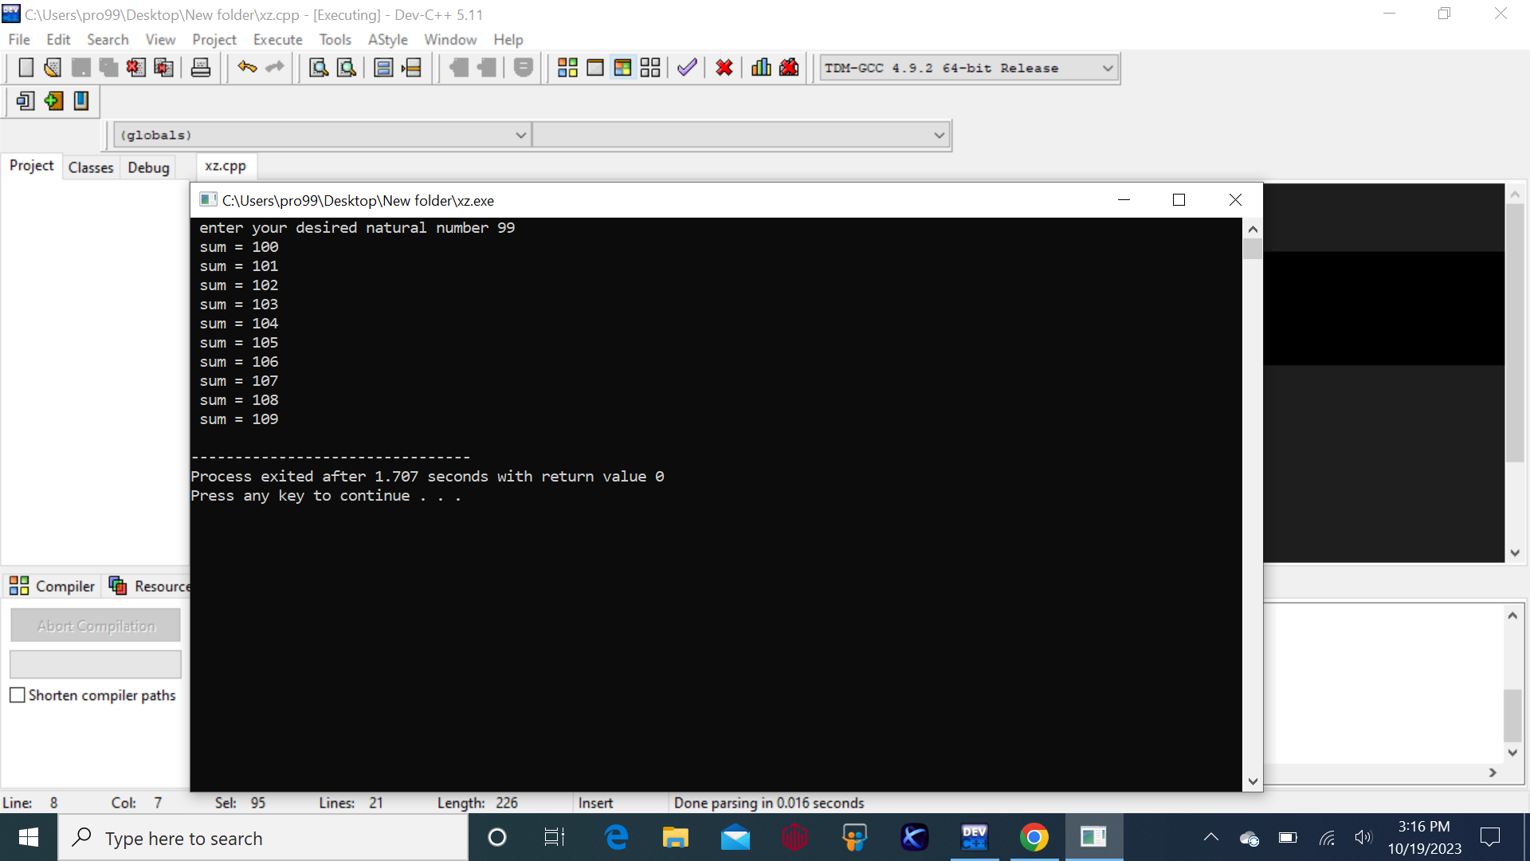

* **Task 2:**

#include<iostream>

using namespace std;

int main(){

//int a,num;

//a=1;

//cout<<"enter your desired number to find its table";

//cin>>num;

//// while(a<=10){

//// cout<<num<<"*"<<a << '=' << num * a <<endl;

//// a++;

//// }

}

**Output:**

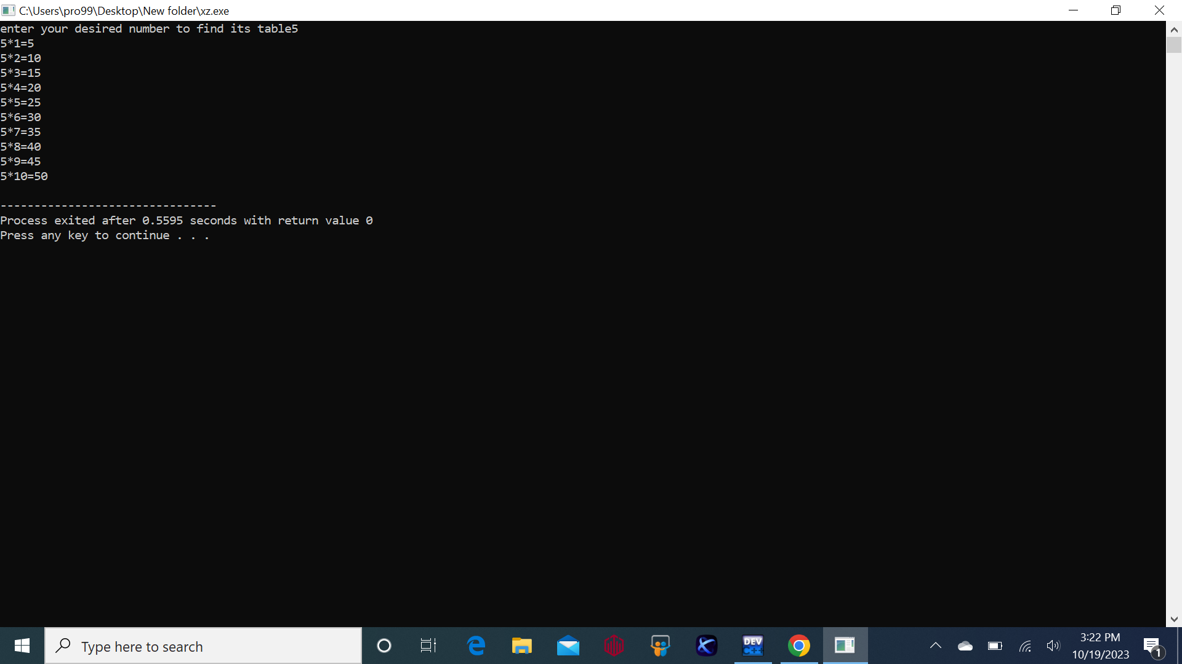

* **Task 3:**

#include<iostream>

using namespace std;

int main(){

int num,a,b;

cout<<"entered your desried number to find its factorial ";

cin>>num;

b=1;

for(a=1;a<=num; ++a){

b *=a;

} cout<<"the factorial of "<< num <<" is "<<num<<"!"<< "=" <<b;

}

**Output:**

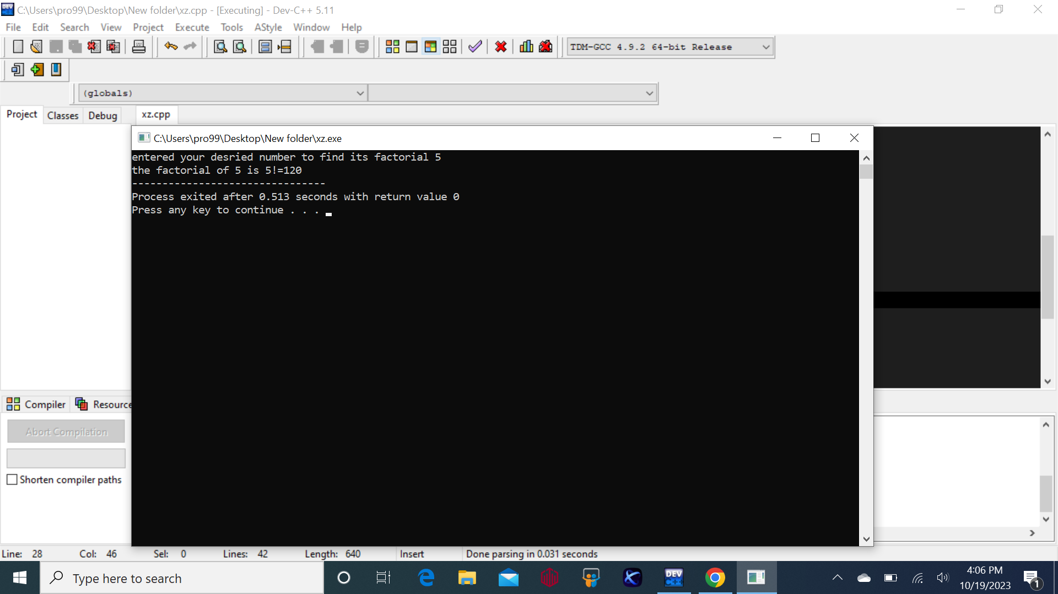

* **Task 4:**

#include<iostream>

using namespace std;

int main(){

//int num,b,a;

//cout<<"enter the numbers upto u want this sequence to run ";

//cin>>num;

//b=0;

//a=1;

//int count=0 ;

//cout<<"the required fibonacci sequence is "<<endl;

//cout<<b<<endl<<a<<endl;

//while(count<num-2){

// int next_value;

// next_value=b+a;

// cout<<next_value<<endl;

// b=a;

// a=next_value;

// count++;

// }

//return 0;

// }

}

**Output:**

